Project 1

Baibin Hong u3185388

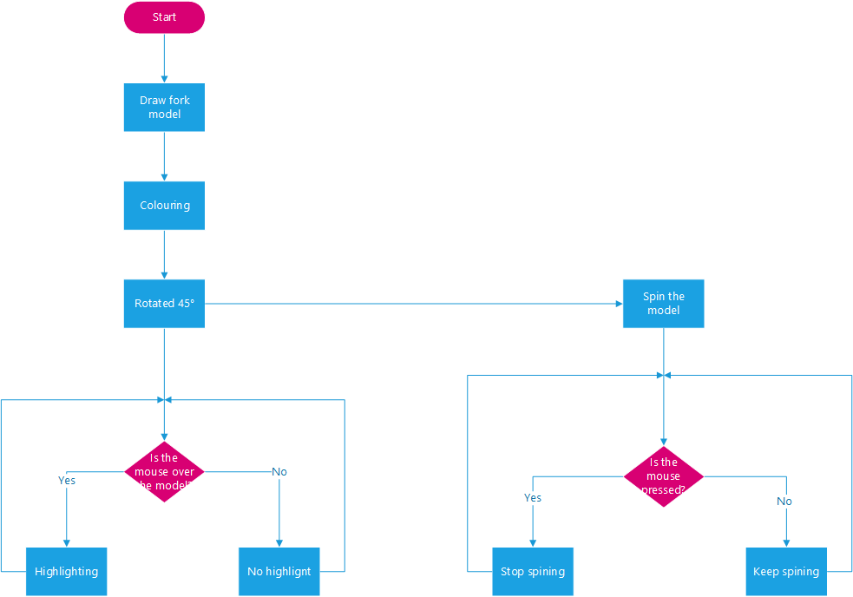

This is a project which is combining a fork model by several types of objects.

Delete the strokes, rotate the entire object to 45 degrees; The handle and blades are filled with gold and silver colours.

The whole object is spinning. When the mouse is in any location of the object, this area will be highlighted; if the mouse has been pressed, the fork will stop in the origin statue.